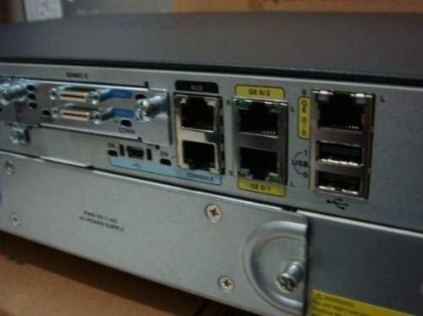

CISCO 2911: Two Router Lab

Two Router Exercise – Part 1

Roll-over cable
Roll-over cable

PC-A

S0/0/0

192.168.3.2
G0/0
PC-B

192.168.1.2 /24
G0/0
192.168.2.2 /24
192.168.2.1 /24
(Gateway)
192.168.1.1 /24
(Gateway)
S0/0/0
Galway
192.168.3.1
Dublin

Step 1:
- Open the file called TwoRouters.pka

Step 2:
- Set the IP address and mask of the PC-A
For example: 192.168.1.2
255.255.255.0
192.168.1.1
- Check that the IP address of the PC-A is configured properly:
Open a DOS window and type ipconfig.
Ping your ip address.
- Left click on the router and then open the CLI tab to connect to Dublin

Step 3:
- Set the IP address and mask of the PC-B
For example: 192.168.2.2
255.255.255.0
192.168.2.1
- Check that the IP address of the PC-B is configured properly:
Open a DOS window and type ipconfig.
Ping your ip address.
- Left click on the router and then open the CLI tab to connect to Galway

After the router finishes the boot process, choose not to use the AutoInstall facility, as shown:

- Enter the following answers to questions:
- Would you like to enter the initial configuration dialog? NO
- Would you like to terminate autoinstall? YES
(Do not allow autoinstall to run and do not enter management configuration mode if prompted)
- You should now have the following prompt, Router>

The following sequence of commands will allow you to configure and test the Gigabit 0/0 port. Testing requires that you use both ping and telnet.

The sequence of commands presented here are for the router called Dublin. If you are using Galway, then consult diagram for relevant ip addresses. If you are on router Galway, then the network address is 192.168.2.0 and you can assign the individual host numbers of 1 and 2 to the router interface and PC respectively.

Type in the following commands to setup the router:
- Router>enable
- Router#configure terminal
- Router(config)#hostname Dublin

- Configure the enable secret password to be "class".
Dublin(config)#enable secret class

- Set the IP address in Gigabit port 0
Dublin(config)#interface G0/0
Dublin(config-if)#ip address 192.168.1.1 255.255.255.0
Dublin(config-if)#no shutdown
Dublin(config-if)#end

No shutdown. Interfaces are shut down by default. Remember to explicitly issue the no shutdown command in interface configuration mode when you are ready to bring up the interface.
Check ip addresses and physical connections:
Dublin#ping 192.168.1.1 → success !!!!!

If ping doesn’t work enter Dublin#show ip interface brief to see the status of attached interfaces
Also ensure that the windows firewall is turned off on both PC’s

- Configure the password to be "console" when someone tries to log in from the console port.
Dublin(conf)#line con 0
Dublin(config-line)#password cisco
- Dublin(config-line)#login
- Dublin(config-line)#logg syn
- Dublin(config-line)#end

Configure the password to be "telnet" when someone tries to telnet into the router.
Dublin#configure terminal
Dublin(conf)#line vty 0 4
Dublin(conf-line)#password cisco
- Dublin(conf-line)#transport input telnet
- Dublin(config-line)#login
- Dublin(config-line)#logg syn
- Dublin(config-line)#end
- Repeat the commands to configure passwords on the Galway router.

Test if telnet is working;

- Open up the cmd prompt window and ping from PC-A to Dublin G0/0
- Test for connectivity and troubleshoot if not working.
- Open up a new Tera Term window
- Select the telnet radio button, in the host field type the address of the router and then OK.
- Test for connectivity/telnet on the Galway router

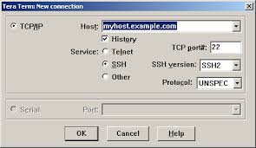

Static Routes - Part 2

In part 2, we want to configure communication between the two routers, Dublin and Galway. This will allow the two LAN networks to "see" each other. There are two ways of configuring routing between the routers, static routing and dynamic routing. Here we will look at the static method and in part 3, you will configure dynamic routing.
On router Dublin, setup the following ip address on serial port s0/0/0. Router Galway use 192.168.3.2 for serial port s0/0/0.

Dublin#configure terminal
Dublin(config)#interface serial 0/0/0
Dublin(config-if)#ip address 192.168.3.1 255.255.255.0
Dublin(config-if)#no shutdown
Dublin(config-if)#clock rate 64000 Only set clock rate in DCE end of cable.
Dublin(config-if)#bandwidth 64
Dublin(config-if)#end
Galway#configure terminal
Galway(config)#interface serial 0/0/0
Galway(config-if)#ip address 192.168.3.2 255.255.255.0
Galway(config-if)#no shutdown
Galway(config-if)#bandwidth 64
Galway(config-if)#end

To test that the serial line is working, type in the following command:
show ip interface brief
If both line and protocol are up, then try pinging the end points of the serial line.
Dublin#ping 192.168.3.2 → success !!!!!

Dublin#show ip route → shows two ip addresses

Is the LAN attached to router Galway in your routing table? ____________
You can not ping student 2 LAN hosts because router Dublin does not know about the third network; i.e. 192.168.2.0 in Dublin case and 192.168.1.0 in Galway case. Need to setup a routing protocol so the routers can exchange information.

On Dublin, type in the following command:

ip route 192.168.2.0 255.255.255.0 S0/0/0

This sets up a static route between routers Dublin and Galway and packets for network 192.168.2.0 will be forwarded through serial port zero on Dublin.

Another way to write this command is

ip route 192.168.2.0 255.255.255.0 192.168.3.2

Ping the PC attached to the network on Galway from network on Dublin.
Were you successful? _____________________

- If not successful, you may need to configure the static route from Galway back to Dublin!
- Before you move onto Part 3, you must remove the static routes from both routers.

Finally, remove the static routes on both routers by typing a no in front of the ip route command,

no ip route 192.168.2.0 255.255.255.0 S0/0/0

Dynamic Routes – Part 3

Static routes require the router's administrator to manually change the commands every time the routes are changed. Another way of setting up routes is to use a routing protocol like RIP or IGRP to dynamically exchange routing tables.

REMOVE any static addresses on both routers.

Setting up dynamic routing.
In our dynamic routing example, we tell the system to use routing protocol RIP and we tell RIP what networks to advertise, (only directly connected networks). RIP doesn’t support subnets and will only see classful network addresses.

Dublin>enable
Dublin#configure terminal
Dublin(config)#router rip
Dublin(config-router)#network 192.168.1.0
Dublin(config-router)#network 192.168.3.0
Dublin(config-router)#end
- Configure the RIP statements for Galway

Note we ONLY advertise the networks that are directly connected to our router.

Now test your connections as before. Look at your routing table and see what networks your router knows about.
What are the responses to the following commands?
- show ip route and show ip protocol

